**Introduction to Angular**

**What is Angular?**

Angular is the most popular web development framework for developing mobile apps as well as desktop applications. The angular framework is also utilized in the cross-platform mobile development called *IONIC*and so it is not limited to web apps only.

Angular is an open source framework written and maintained by the angular team at *Google*and the Father of Angular is '*Misko Hevery'*. The bootstrapping process creates the components listed in the bootstrap array and inserts each one into the browser (DOM).

It was written in TypeScript, Angular implements core and additional functionality as a set of TypeScript libraries. These are imported to Angular apps. which is completely based on components.

**Why Angular?**

There are many front-end JavaScript frameworks to choose from today, each one is having their own benefits. Angular made it faster, more scalable and modern and was written in Typescript, a superset of JavaScript.

Let’s have a look at the main benefits that makes Angular stand out.

**TypeScript**: As mentioned earlier Angular was written in Typescript, which is basically a super set of JavaScript. It fully compiles to JavaScript.

**Data Binding**: If there is one feature that Angular made us go “Wow”, then it was probably its two-way data binding system.

**Routing:** It Provides a service that lets you define a Navigation path among the different application states and view hierarchies in your app. The router maps URL-like paths to views instead of pages.

**Component-based architecture:** Components can be thought of as small pieces of user interface, like a section of the application. They allow you to control the UI of your app with Reusability, Readability, Maintainability are the benefits.

**Integration:** It helps you to integrate the third-party features into the application you are building.

**High Performance:** Multiple factors can help in making your application faster. The main boost is ensured by hierarchical dependency injection and Angular Universal support.

**History:**

**Angular1.0/Angular JS:**

The first version of Angular was Angular1.0 (also known as AngularJS) which was released in 2010. But here, we are talking about Angular so; let's see history and different versions of Angular.

**Angular2:**

Angular 2.0 was first introduced in October 2014. It was a complete rewrite of Angular so, the drastic changes in the 2.0 version created controversy among developers. On April 30, 2015, the Angular developers announced that Angular 2 moved from Alpha to Developer Preview and then Beta version was released in December 2015. Its first version was published in May 2016 and the final version was released on September 14, 2016.

**Angular4:**

Angular 4 version was announced on 13 December 2016. The developers skipped the version 3 due to some confusion. Its final version was released on 23 March 2017.

This version has some additional features:

* This version introduced Http Client, a smaller, easier to use, and more powerful library for making HTTP Requests.
* It provides new router life cycle events for Guards and Resolvers. Four new events: GuardsCheckStart, GuardsCheckEnd, ResolveStart, ResolveEnd join the existing set of life cycle event such as NavigationStart.
* It provides the support of conditionally disable animations.

**Angular5:**

This version was released on 1 Nov, 2017. It provided some improvements to support for progressive web apps, also provides improvements related to Material Design.

**Angular6:**

This version was released on 4 may, 2018. It was a major release which provides some features like: ng update, ng add, Angular Elements, Angular Material + CDK Components, Angular Material Starter Components, CLI Workspaces, Library Support, Tree Shakable Providers, Animations Performance Improvements, and RxJS v6.

**Angular 7:**

The latest version of Angular is Angular 7. It was released on October 18, 2018. This Version is primarily focused on the Ivy project, which has been going on since past release.

The Ivy project is basically rewriting the Angular compiler and runtime code to make it better, faster, and smaller.

It consists of many extensive features:

**1. CLI prompts**

In Angular 7, the CLI prompts have been updated to v7.0.2 with new features. For instance, it will now prompt users when typing commands like @angular/material, ng-new, and ng-add to help them discover the in-built SCSS support, routing, and more.

These CLI prompts, in addition, have been added to Schematics, so that all package publishing schematics can now benefit from CLI prompts.

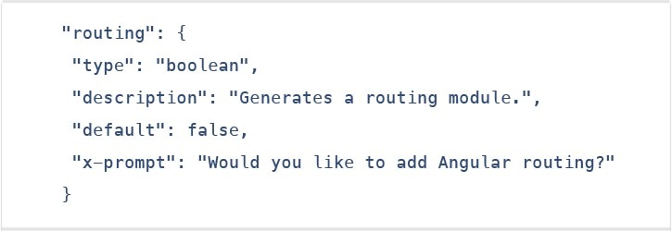

**2. Angular material & component dev kit (CDK)**

The Angular 7 introduced minor visual updates & improvements in Material Design that earlier received a major update this year only.

In addition, refresh, virtual scrolling, large lists of data, dynamic loading and unloading of parts of the DOM also were the part of improvements in CDK and Angular Material.

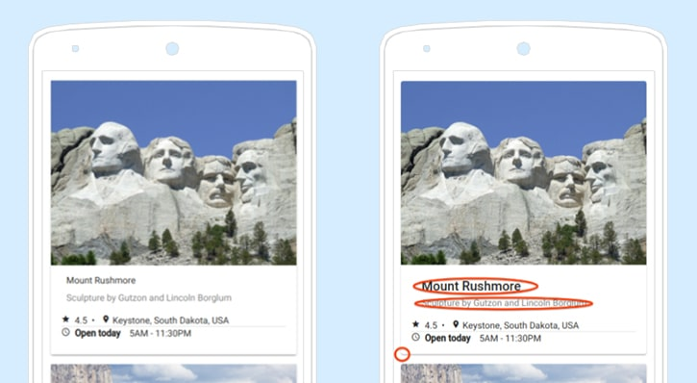

**3. Drag & drop**

The new drag-drop module basically provides a better way to easily create drag & drop interfaces, which is backed by sorting within a list, support for free dragging, animations, custom drag handles, transferring items between lists, previews, and placeholders.

In simple terms, the Drag-and-Drop support has now been implemented in CDK and it also includes automatic rendering as the users relocates items.

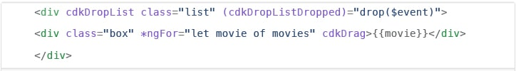

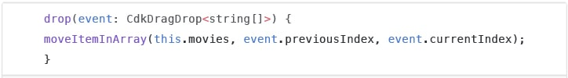

**4. Virtual scrolling**

Like mentioned earlier, the new Virtual Scrolling in Angular 7 basically loads and unloads items from the DOM depending upon visible parts of lists, resulting into a much faster experiences for users having huge scrollable lists.

This virtual scrolling package basically provides helpers, which react to all scroll events.

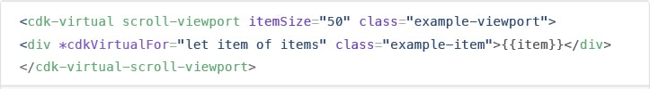

Simply put, it activates a high-performant way by making the height of container element exactly same as the height of total number of remaining elements to be rendered.

This, in turn, then renders the only visible items in view, creating faster experiences for the end-users.

**5. Application performance improvements**

The development team at Google have always focused on the performance improvements, and while doing so, they recently found that most of the developers were using reflect-metadata in their production, which actually was only required in the development.

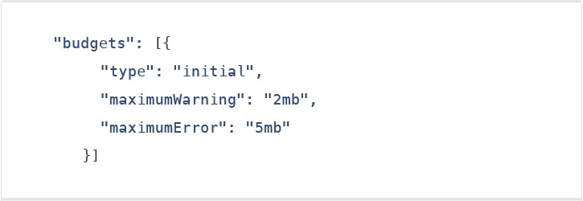

**6. No Ivy**

No Ivy rendered in the Angular 7 according to the official information. The Angular JS Development Company’s team have said that the Ivy is in the pipeline; however, they haven’t disclosed its final timeline.

The official blog post also mentioned that the backward compatibility validation has begun. And its full beta version is expected to launch with Angular 8 version.

**7. Documentation updates**

Another key improvement introduced in the Angular 7 is of the documentation update. The team has worked hard on improving the reference material and the guidelines for the betterment and convenience of the developers.

The documentation updates for Angular is an important step for the Angular CLI.

**8. Dependency updates**

Documentation are not the only things that have been updated. Even the dependencies have undergone upgradation for the third-party projects.

The support for Node 10, TypeScript3.1, and the RxJS6.3 all are included under this update.

However, you would continue to receive the support if you already have Node 8. Talking about the latest update of TypeScript 3.1, it has now become compulsory for Angular 7 users to bump to TS 3.1.

**Comparison:**

**Comparison between Angular & Angular JS:**

|  |  |
| --- | --- |
| **Angular JS** | **Angular** |
| Released by Google in the year 2010. | Released in Sept 2016. |
| JavaScript-based framework for creating SPA. | Complete re-write of AngularJS version. |
| Still supported but no longer will be developed. | It's updated version regularly released because of Semantic Versioning. |
| The architecture of AngularJS is based on MVC. | The architecture of Angular 2 is based on service/controller. |
| AngularJS was not developed with a mobile base in mind. | Angular 2 is a mobile-oriented framework. |
| AngularJS code can write by using only ES5, ES6, and Dart. | We can use ES5, ES6, Typescript to write an Angular 2 code. |
| Based on controllers whose scope is now over. | Nowadays, the controllers are replaced by components, and Angular two is completely component based. |
| Factory, service, provider, value and constant are used for services | The class is the only method to define services in Angular2 |
| Run on only client-side | Runs on client-side & server-side |
| ng-app and angular bootstrap function are used to initialize | bootstrapmodule() function is used to initialize |

**Comparison between Angular & React:**

React and Angular are two very popular front-end development tools. There are three major elements of concern:

* **HTML:** Used to build the structure of your web page.
* **CSS:** Used to format the appearance of different structural elements.
* **JavaScript:** A programming language used to describe the functionality and handle all the dynamic elements on the web page.

So how do Angular, a framework, and React, a library, compare with each other? Let’s break down the term’s framework and library first.

**Framework:** A software framework (be it front-end or backend) includes standardized, pre-written code, which makes the development of certain functionalities easier and faster. You have less freedom to code, as you have to code as the framework architecture dictates.

**Library:** A library is a collection of functions and functionalities, which you can use to achieve a certain end. You have more freedom to design and construct the system when using a library, but that adds more responsibility on the coder to be able to use it efficiently and find the right library for the right job, because, for projects which need to grow over time and become more serious, this could become significantly riskier and more difficult to manage.

|  |  |  |  |
| --- | --- | --- | --- |
| **Technology** | **React JS** | **Angular JS** | **Angular** |
| **Latest Version** | 16.8 (February 2019) | 1.7.7 (February 2019) | Angular 8 *(to be released in March/April 2019) |
| **Author** | Facebook Community | Google | Google |
| **Type** | Open Source JS library | Fully-featured MVC framework | Fully-featured MVC framework |
| **Tool Chain** | High | Low | High |
| **Language** | JSX | JavaScript, HTML | TypeScript |
| **Learning Curve** | Low | High | Medium |
| **Packaging** | Strong | Weak | Medium |
| **Rendering** | Server Side | Client Side | Server Side |
| **App Architecture** | None, combined with Flux | MVC | Component-Based |
| **Data Binding** | Uni-Directional | Bi-Directional | Bi-Directional |
| **DOM** | Virtual DOM | Regular DOM | Regular DOM |
| **Native Application Development Support** | Available (React Native) | Available | Available |

Now that you know the major differences in Angular and React, let’s find out what to use and when:

**React** is pretty much ideal for logic less applications or computation-less apps. In cases where you need a custom solution, React will best suit your needs because, with React, you can build almost anything.

Especially if you are building:

* Dynamic Applications
* Single Page Apps
* Native Mobile Apps

**Angular** is best for creating:

* Cross-platform Mobile Apps
* Enterprise Software
* Progressive web apps and hybrid mobile apps

**EXAMPLE:**

<https://coursetro.com/posts/code/171/Angular-7-Tutorial---Learn-Angular-7-by-Example>